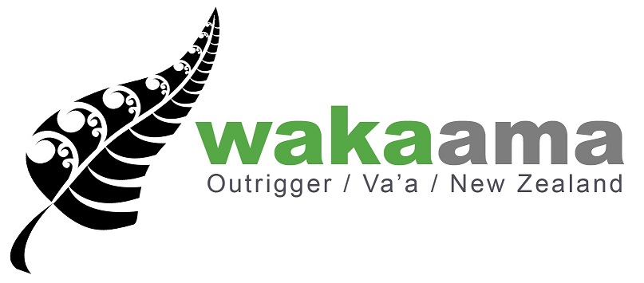


ELECTED BOARD MEMBER NOMINATION FORM
Name of Nominee
Contact Email:
Contact Phone:

Name of nominating Club/Region:
Contact Email:

Nomination Forms must be typed. Handwritten nominations will not be accepted
Please use extra pages as necessary and attach a CV relevant to this nomination

- Reason for Nomination: (To be completed by Member Club / Region)

Nominee Profile: (500 word Max, to be completed by Nominee)
This information will be posted on the wakaama.co.nz website for member clubs to vote on if the nominee is shortlisted.

- Nominee statement: Why you wish to be a Board member of Nga Kaihoe o Aotearoa/Waka Ama New Zealand? (in 300 words or less)

- Please identify below the key skills from the Board Skills Matrix (below) which you believe you will bring to the role, and provide evidence of those skills in the space below:

Whole of Board Skills Matrix 2015- 2020 and beyond
Leadership | Financial literacy and analytical ability | Outcomes focused | A knowledge of Tikanga Maori
Marketing & Communications | Inter-personal communication skills | Ethical, open, honest, trustworthy, high levels of integrity | Strategic Thinking
Ability to understand and relate to stakeholders | Ability to work as a team player | Business acumen | Knowledge of legal issues relating to business or the not for profit sector
The Sport of Waka Ama knowledge | Strong local and national community connection, credibility and networks | Ability to establish quality relationships | Good understanding of the principles of Governance and Management
Te Reo Māori | Knowledge and application of Te Tiriti o Waitangi/Treaty of Waitangi in governance | Commitment to diversity and inclusion | Uphold the values of Nga Kaihoe o Aotearoa, Waka Ama New Zealand
In particular, we are looking for board members that hold skills in the areas highlighted in blue.
- Final Checklist:

Please Tick:
I can commit to attending 4 meetings per year
I am aware of my liabilities as a director
I have read the Nga Kaihoe O Aotearoa (Waka Ama NZ) constitution - Link attached here: http://www.wakaama.co.nz/content/page/8/attachments/Waka_Ama_NZ_Constitution_January_2013.pdf
Potential Board members should understand, from the outset of the election process, the legal obligations of being a member of a Board:
Board members exercise stewardship responsibility on behalf of others (usually as members of an incorporated society or beneficiaries of a charitable trust). The Board is responsible for:
- the achievement of appropriate outcomes;
- acting in the best interests of the organisation as a whole
- the financial security of the organisation; and
- the expression of a moral and social responsibility to the sport and to its members.

Joint liability – all Board directors are equally liable for actions and decisions taken by the Board. Non-attendance at a meeting at which a decision is made doesn’t absolve a director from shared responsibility, accountability or liability.

Nominations can be made by Member Clubs or Member Regions. You can nominate any individual. Nominees do not need be a member/paddler of your club or region. However the individual cannot be an existing member of one of the 6 Waka Ama Regional Boards/Committees (TTPCA, AROCA, TPOTI, TUOTR, HTPWAA, TWOA)

Please email to admin@wakaama.co.nz by 5pm on Friday 4th October 2019
we will reply to confirm your nomination has been received
A shortlisting panel (as per constitution 9.4) will short list up to six nominees for the election. All shortlisted nominees will be profiled on the www.wakaama.co.nz website.
For further information please contact
Email: admin@wakaama.co.nz

